DFSC 5340.02 Assignment 8
Due: Thursday December 10th@11:59PM
Total Points: 110

- (40 pts) Use software or write Python/Matlab/R script to analyze the Crime2 data file that is attached, excluding the observation for D.C. Let y = mur-der rate. For the five explanatory variables in that data file (excluding violent crime rate), with α = 0.10 in tests,
(a) Use backward elimination to select a model. Interpret the result.

(b) Use forward selection to select a model. Interpret the result.

(c) Compare results of the two selection procedures. How is it possible that a variable (percentage with a high school education) can be the first variable dropped in (a) yet the second added in (b)?

(d) Now include the D.C. observation. Repeat (a) and (b), and compare to results excluding D.C. What does this suggest about the influence outliers can have on automatic selection procedures?

- (30 pts) For a data set for 100 adults on y = height, x₁ = length of left leg, and x₂ = length of right leg, the model E(y) = α + β₁x₁ + β₂x₂ is fitted. Neither H₀: β₁ = 0 nor H₀: β₂ = 0 has a P-value below 0.05.
(a) Does this imply that length of leg is not a good predictor of height? Why?

(b) Does this imply that H₀: β₁ = β₂ = 0 would not have a P-value below 0.05? Why?

(c) Suppose r_{yx1} = 0.901, r_{yx2} = 0.902, and r_{x1x2} = 0.999. Using forward selection and the potential predictors x₁ and x₂ with α = 0.05 for tests, which model would you expect to be selected? Why?

- (40 pts) For white men in the United States, the following Table presents the number of deaths per thousand individuals of a fixed age within a period of a year.
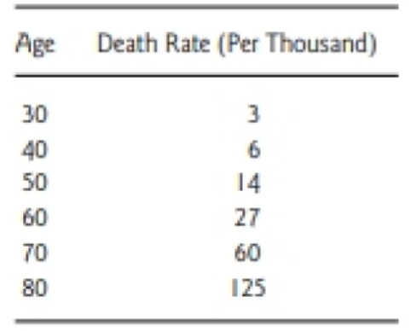

(a) Plot x = age against y = death rate and against log y. What do these plots suggest about a good model for the relationship?

(b) Find the correlation between (i) x and y, (ii) x and log(y). What do these suggest about an appropriate model?

(c) Using generalized linear models, find the prediction equation for the model log[E(y)] = α + βx.

(d) Find the prediction equation for . Interpret the parameter estimates.

